**Front end**

**First Appearance:**

In an increasingly web-based world, a webpage is often the first impression as well as the first interaction with customers. When we discuss the “frontend” of the web, what we’re really talking about is the part of the web that you can see and interact with.

The front end is an interface between the user and back end or in the other words it’s basically the presentation layer.

In order to create a responsive design we used bootstrap framework which contains [HTML](https://en.wikipedia.org/wiki/HTML)- and [CSS](https://en.wikipedia.org/wiki/CSS)-based design templates for [typography](https://en.wikipedia.org/wiki/Typography) forms, buttons, navigation and other interface components, as well as optional [JavaScript](https://en.wikipedia.org/wiki/JavaScript) extensions.

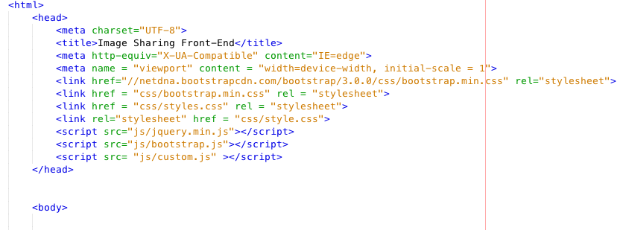

**Responsive design:**

**\*Collapse Navigation bar**

We used <nav> element for navigation and make it responsive, we use collapse JQuery plugin for the navbar. After using it, when we make the web application smaller size, it become a hamburger menu instead of displaying all the menus in a row.

**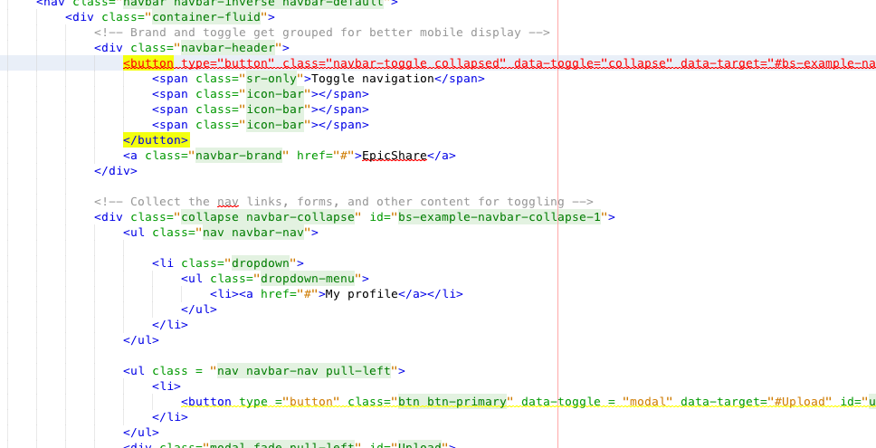**

**\*Grid system**

**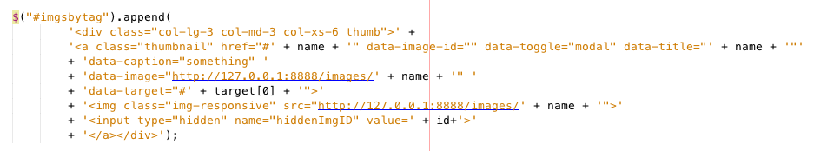**

For making responsive web application, we used a grid system. We define <div class = “col-lg-3 col-md-3 col-xs-6 thumbs”> to define how many columns can be inside of one row, depending on the device sizes. We could display 4 images in a row in our laptop which is 13 inches size and in the phone, we could display 2 images in a row.

**ex) Laptop size(13 inches) : 4 images in a row**

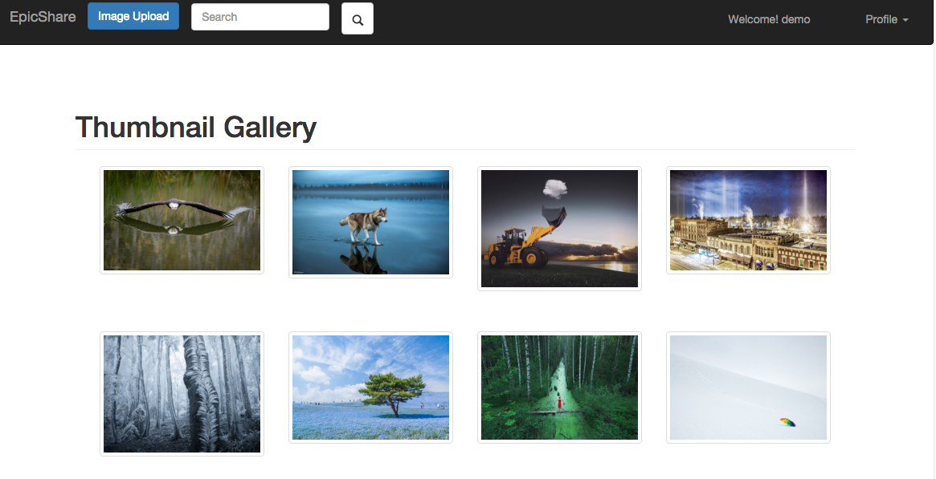

ex) **Collapse Navigation bar & 2 images in a row**

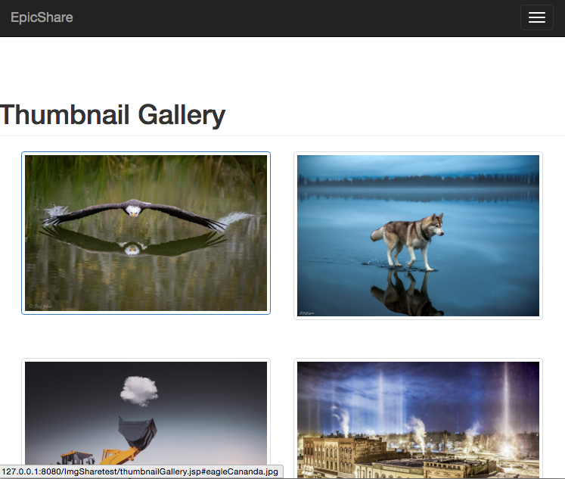

**Some of the features we used:**

-Buttons: We used sign up and log in buttons in the front page before user log in. Like and Dislike buttons after the user clicks on the image, submit button for commenting and upload button for image uploading.

-modals : We used modals for Sign up and log in function to prompt a dialog window/popup box so that user can put his/her information (username, password, email) in order to register or log in. And it is also used for displaying images. wWhen users click the each image, The each image pops up with modals to show image itself and image metadata(image name, image category, image path).

Modal + Form (inside the modal body)

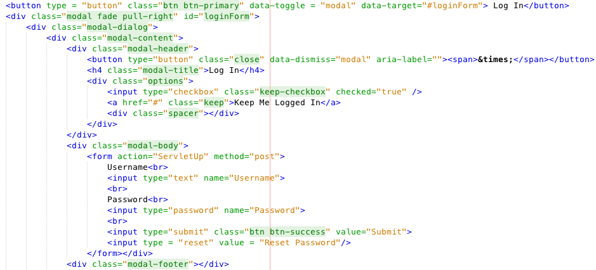

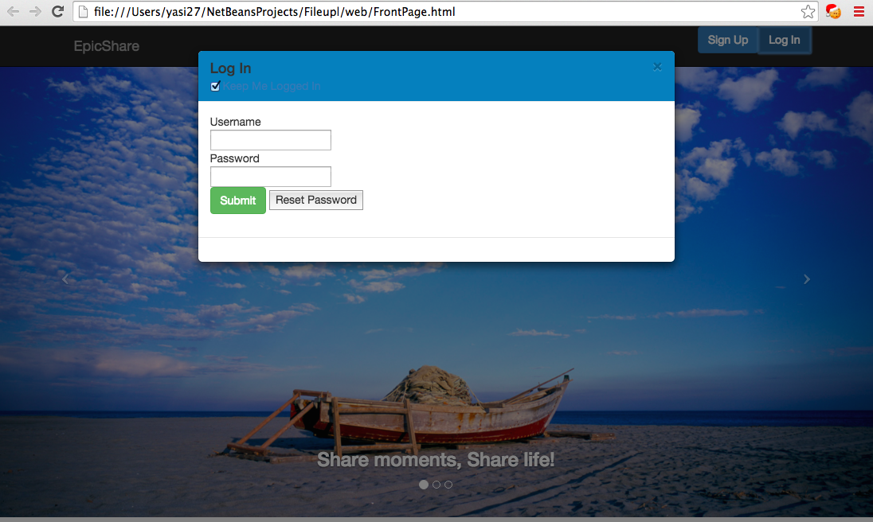

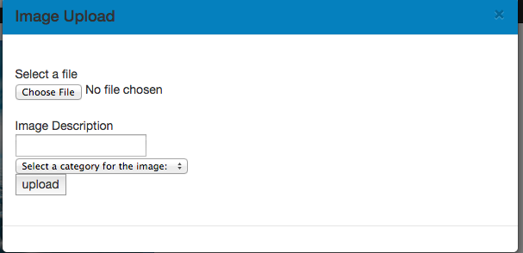

-Color-modals:

Change the colors of the modals in the first front page(sign up and log in function)

Blue rgb : background-color: #0480be

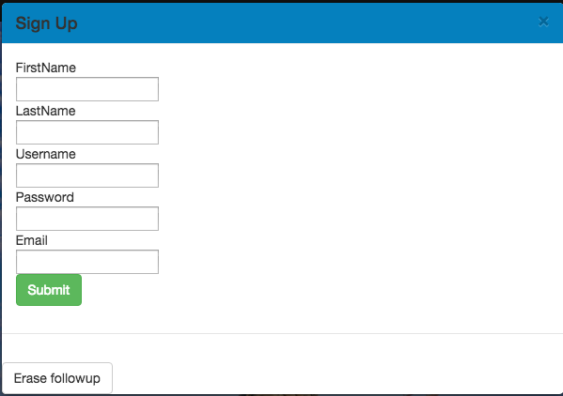

-Carousel : Image slider (auto-slide) in the first front page using Carousel.

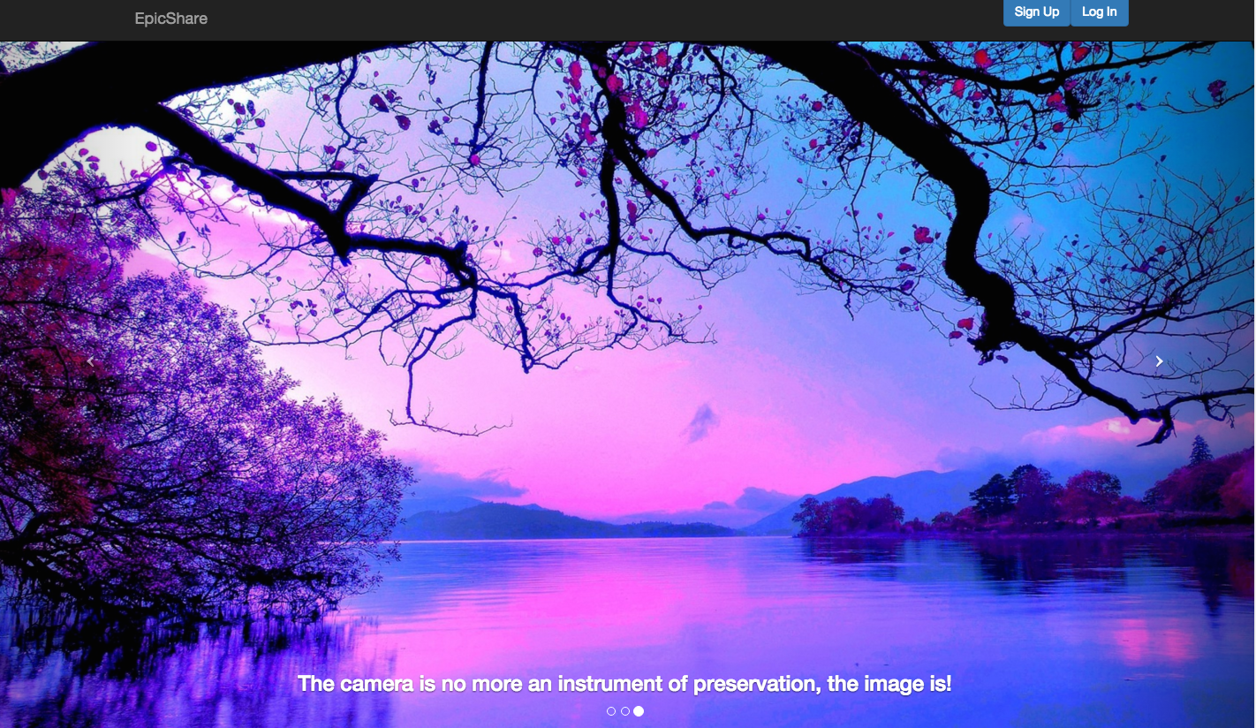

-Icons : glyphicon thumbs-up and glyphicon thumbs-down for like and dislike buttons and also glyphicon-search for searching function.

OSX_YOSE:Users:iosdev:Desktop:Screen Shot 2015-12-14 at 8.02.22 PM.png

Macintosh HD:Users:yasi27:Desktop:Screen Shot 2015-12-11 at 14.28.43.png